**Host Multiple Websites on a Single Server with Apache on Ubuntu 18.04**

**There are three ways to host multiple websites on a single server:**

1. Name-based Virtual Hosting.
2. IP-based Virtual Hosting.
3. Port-based Virtual Hosting.

## **Step 1 – Create an Atlantic.Net Cloud Server**

Once you are logged into your Ubuntu 18.04 server, run the following command to update your base system with the latest available packages.

apt-get update -y

## Step 2 – Install Apache Web Server

apt-get install apache2 -y

Once the installation is completed, start the Apache service with the following command:

systemctl start apache2

## Name-Based Virtual Hosting

Name-based virtual hosting is the most commonly used method to host multiple websites on the same IP address and Port.  You will need valid domain names to host multiple websites using name-based virtual hosting.

In this section, we will use [site1.example.com](http://site1.example.com/) and [site2.example.com](http://site2.example.com/) to host two websites on a single server.

### Step 3 – Create a Directory Structure

First, create a document root directory for both websites:

mkdir /var/www/html/site1.example.com

mkdir /var/www/html/site2.example.com

Next, create an **index.html** page for both websites.

First, create an **index.html** page for [**site1.example.com**](http://site1.example.com/):

nano /var/www/html/site1.example.com/index.html

Add the following lines:

<html>

<title>site1.example.com</title>

<h1>Welcome to [site1.example.com](http://site1.example.com/) Website</h1>

<p>This is my first website hosted with name-based virtual hosting</p>

</html>

Next, create an **index.html** page for [**site2.example.com**](http://site2.example.com/):

nano /var/www/html/site2.example.com/index.html

Add the following lines:

<html>

<title>site2.example.com</title>

<h1>Welcome to [site2.example.com](http://site2.example.com/) Website</h1>

<p>This is my second website hosted with name-based virtual hosting</p>

</html>

Next, change the ownership of [**site1.example.com**](http://site1.example.com/) and [**site2.example.com**](http://site2.example.com/) directory to **www-data**:

chown -R www-data:www-data /var/www/html/site1.example.com

chown -R www-data:www-data /var/www/html/site2.example.com

### Step 4 – Create a Virtual Host Configuration File

Next, you will need to create an Apache virtual host configuration file to serve both websites.

First, create an Apache virtual host configuration file for [**site1.example.com**](http://site1.example.com/):

nano /etc/apache2/sites-available/site1.example.com.conf

Add the following lines:

<VirtualHost *:80>

ServerAdmin admin@site1.example.com

ServerName [site1.example.com](http://site1.example.com/)

DocumentRoot /var/www/html/site1.example.com

DirectoryIndex index.html

ErrorLog ${APACHE_LOG_DIR}/site1.example.com_error.log

CustomLog ${APACHE_LOG_DIR}/site1.example.com_access.log combined

</VirtualHost>

Save and close the file.

Next, create an Apache virtual host configuration file for [**site2.example.com**](http://site2.example.com/):

nano /etc/apache2/sites-available/site2.example.com.conf

Add the following lines:

<VirtualHost *:80>

ServerAdmin admin@site2.example.com

ServerName [site2.example.com](http://site2.example.com/)

DocumentRoot /var/www/html/site2.example.com

DirectoryIndex index.html

ErrorLog ${APACHE_LOG_DIR}/site2.example.com_error.log

CustomLog ${APACHE_LOG_DIR}/site2.example.com_access.log combined

</VirtualHost>

Save and close the file. Then, enable the virtual host configuration file with the following commands:

a2ensite [site1.example.com](http://site1.example.com/)

a2ensite [site2.example.com](http://site2.example.com/)

Next, restart the Apache webserver to apply the configuration changes:

systemctl restart apache2

### Step 5 – Test Both Websites

At this point, you have configured the Apache webserver to serve two websites.

Now, open your web browser and type the URL [http://site1.example.com](http://site1.example.com/). You should see your first website in the following screen:

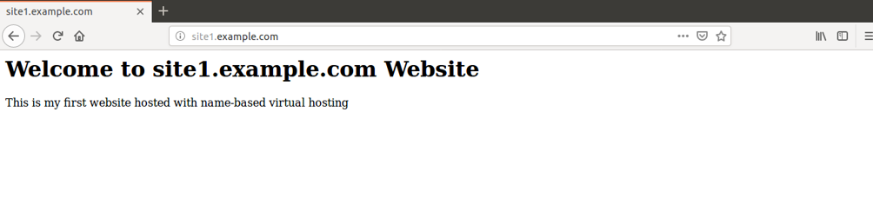

Next, open your web browser and type the URL [http://site2.example.com](http://site2.example.com/). You should see your second website in the following screen:

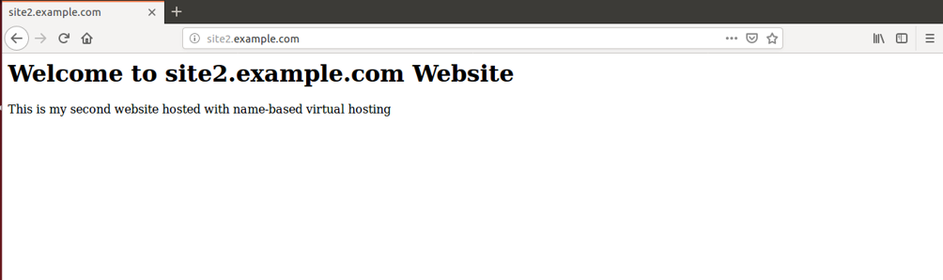

## IP-Based Virtual Hosting

IP-based virtual hosting is a method to serve different websites based on IP address. You can assign a separate IP address for each website on a single server.

In this section, we will use the IP addresses 192.168.0.101 and 192.168.0.102 to host two websites on a single server.

### Step 3 – Create a Directory Structure

First, create a document root directory for both websites:

mkdir /var/www/html/192.168.0.101

mkdir /var/www/html/192.168.0.102

Next, create an **index.html** page for both websites.

First, create an **index.html** page for the website hosted on **192.168.0.101**:

nano /var/www/html/192.168.0.101/index.html

Add the following lines:

<html>

<title>192.168.0.101</title>

<h1>Welcome to 192.168.0.101 Website</h1>

<p>This is my first website hosted with IP-based virtual hosting</p>

</html>

Save and close the file.

Next, create an **index.html** page for the website hosted on **192.168.0.102**:

nano /var/www/html/192.168.0.102/index.html

Add the following lines:

<html>

<title>192.168.0.102</title>

<h1>Welcome to 192.168.0.102 Website</h1>

<p>This is my first website hosted with IP-based virtual hosting</p>

</html>

Save and close the file.

Next, change the ownership of both websites to www-data:

chown -R www-data:www-data /var/www/html/192.168.0.101

chown -R www-data:www-data /var/www/html/192.168.0.102

### Step 4 – Create a Virtual Host Configuration File

Next, you will need to create an Apache virtual host configuration file to serve both websites.

First, create an Apache virtual host configuration file for the website hosted on 192.168.0.101:

nano /etc/apache2/sites-available/192.168.0.101.conf

Add the following lines:

<VirtualHost *:80>

ServerAdmin admin@localhost

ServerName  192.168.0.101

DocumentRoot /var/www/html/192.168.0.101

DirectoryIndex index.html

ErrorLog ${APACHE_LOG_DIR}/192.168.0.101_error.log

CustomLog ${APACHE_LOG_DIR}/192.168.0.101_access.log combined

</VirtualHost>

Save and close the file.

Next, create an Apache virtual host configuration file for the website hosted on 192.168.0.102:

nano /etc/apache2/sites-available/192.168.0.102.conf

Add the following lines:

<VirtualHost *:80>

ServerAdmin admin@localhost

ServerName  192.168.0.102

DocumentRoot /var/www/html/192.168.0.102

DirectoryIndex index.html

ErrorLog ${APACHE_LOG_DIR}/192.168.0.102_error.log

CustomLog ${APACHE_LOG_DIR}/192.168.0.102_access.log combined

</VirtualHost>

Save and close the file. Then enable the virtual host with the following command:

a2ensite 192.168.0.101

a2ensite 192.168.0.102

Finally, restart the Apache webserver to apply the changes:

systemctl restart apache2

### Step 5 – Test Both Websites

At this point, you have configured Apache webserver to serve two websites.

Now, open your web browser and type the URL [http://192.168.0.101](http://192.168.0.101/). You should see your first website in the following screen:

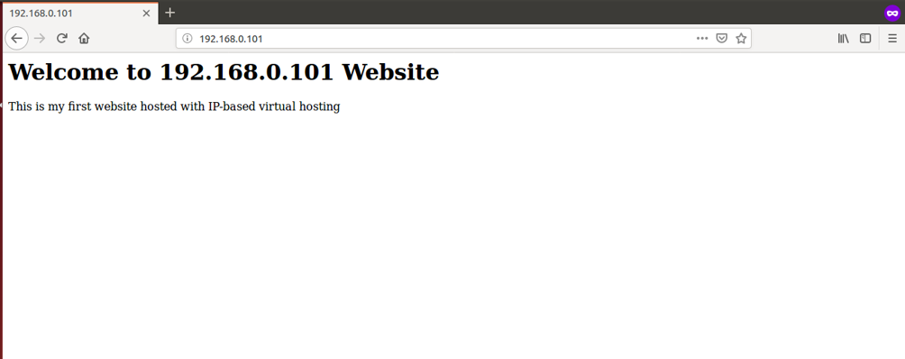

Next, open your web browser and type the URL [http://192.168.0.102](http://192.168.0.102/). You should see your second website in the following screen:

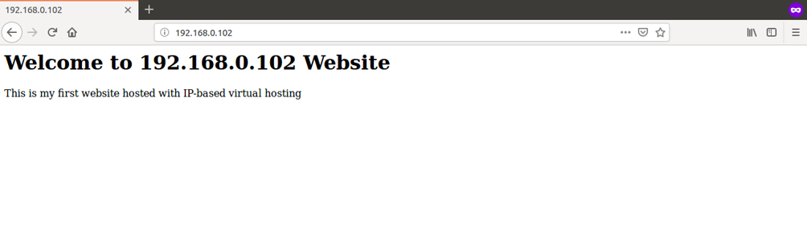

## Port-Based Virtual Hosting

Port-based virtual hosting is a method to serve different websites based on the port number. You can assign a separate port number for each website on a single server with a single IP address.

In this section, we will use the ports numbered 8080 and 8081 to host two websites on a single server with IP address 192.168.0.101.

### Step 3 – Configure Apache to Listen on Port 8080 and 8081

First, you will need to configure the Apache webserver to listen on port **8080** and **8081**. You can do it by editing the file **/etc/apache2/ports.conf**:

nano /etc/apache2/ports.conf

Add the following lines exact below the line **Listen 80**:

Listen 8080

Listen 8081

Save and close the file when you are finished.

### Step 4 – Create a Directory Structure

First, create a document root directory for both websites:

mkdir /var/www/html/8080

mkdir /var/www/html/8081

Next, create an **index.html** page for both websites.

First, create an **index.html** page for the website hosted on port **8080**:

nano /var/www/html/8080/index.html

Add the following lines:

<html>

<title>8080</title>

<h1>Welcome to 8080 Website</h1>

<p>This is my first website hosted with Port-based virtual hosting</p>

</html>

Save and close the file.

Next, create an **index.html** page for the website hosted on port **8081**:

nano /var/www/html/8081/index.html

Add the following lines:

<html>

<title>8081</title>

<h1>Welcome to 8081 Website</h1>

<p>This is my first website hosted with Port-based virtual hosting</p>

</html>

Save and close the file.

Next, change the ownership of both website to www-data:

chown -R www-data:www-data /var/www/html/8080

chown -R www-data:www-data /var/www/html/8081

### Step 5 – Create a Virtual Host Configuration File

Next, you will need to create an Apache virtual host configuration file to serve both websites.

First, create an Apache virtual host configuration file for the website hosted on port **8080**:

nano /etc/apache2/sites-available/8080.conf

Add the following lines:

<VirtualHost 192.168.0.101:8080>

ServerAdmin admin@localhost

ServerName  192.168.0.101

DocumentRoot /var/www/html/8080

DirectoryIndex index.html

ErrorLog ${APACHE_LOG_DIR}/8080_error.log

CustomLog ${APACHE_LOG_DIR}/8080_access.log combined

</VirtualHost>

Save and close the file.

Next, create an Apache virtual host configuration file for the website hosted on port **8081**:

nano /etc/apache2/sites-available/8081.conf

Add the following lines:

<VirtualHost 192.168.0.101:8081>

ServerAdmin admin@localhost

ServerName  192.168.0.101

DocumentRoot /var/www/html/8081

DirectoryIndex index.html

ErrorLog ${APACHE_LOG_DIR}/8081_error.log

CustomLog ${APACHE_LOG_DIR}/8081_access.log combined

</VirtualHost>

Save and close the file. Then, enable the virtual host with the following command:

a2ensite 8080

a2ensite 8081

Finally, restart the Apache webserver to apply the changes:

systemctl restart apache2

### Step 6 – Test Both Websites

At this point, you have configured Apache webserver to serve two websites.

Now, open your web browser and type the URL [http://192.168.0.101:8080](http://192.168.0.101:8080/). You should see your first website per the following screen:

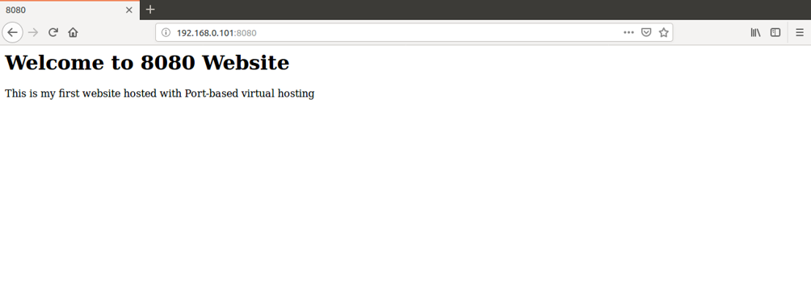

Next, open your web browser and type the URL [http://192.168.0.101:8081](http://192.168.0.101:8081/). You should see your second website per the following screen:

